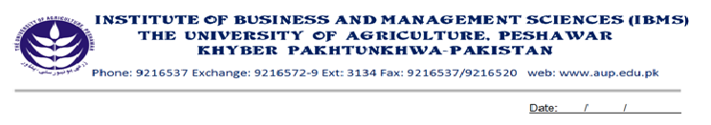
Program: BS(CS)-VII
Course Title: Data & Network Security
Course Code: 605
Session: 2009-2012
Course Hours: 03
Total Weeks: 16
Total Credit Hours: 48
Course Objective
Often there has been a need to protect information from 'prying eyes'. In the electronic age, information that could otherwise benefit or educate a group or individual can also be used against such groups or individuals. Industrial espionage among highly competitive businesses often requires that extensive security measures be put into place. And, those who wish to exercise their personal freedom, outside of the oppressive nature of governments, may also wish to encrypt certain information to avoid suffering the penalties of going against the wishes of those who attempt to control. So this course will help to secure information from eavesdroppers.

Week-1
- Introduction to Cryptography
- Services of Cryptography
- Components of a Cryptographic system
- Attacks on Encrypted schemes
- Cipher text only
- Known plain text
- Chosen plain text
Week-2
- Types of Cryptography
- Private Key Cryptography
- Public Key Cryptography
- Hash Algorithm

Week-3
- Famous Algorithm of Private Key Cryptography (DES & IDEA)
- DES (Data Encryption Standard)
- Initial & Final Permutation
- DES Round
- Per-Round Key generation
- Mangler function

Week-4
- Using Secret/Private Key Cryptography to Encrypt Large Messages
- Electronic Code Book
- Cipher Block Chaining

Week-5
- Modular Mathematics
- Method to Encrypt messages

Week-6
- Congruence
- Totient function

Week-7
- RSA Public Key System
- Trapdoor
- Deffie-Hellman Algorithm

Week-8
- Authentication
- Password Based
- Address Based
- Cryptographic Based

Week-9
- Hash Algorithm/Message Digest
- MD2
- MD4

Week-10
- Digital Signature
- Trusted Intermediaries
- Key Distribution Protocol
Week-11
- Digital Certificate
- Certification Authority
- Certificate Revocation List(CRL)
Week-12
- Overview of Microsoft Certificate Server
- Certificate Server Configuration
- Certificate Server features
- Certificate Sever Architecture
- Server Engine
- Intermediary
- Server Database

Week-13
- Kerberos
- Notation
- Simple Authentication
- Establish Secure Channels

Week-14
- Assumption of Kerberos and ticket
- Attacks against IP

Week-15
- Firewalls
- Packet Filter
- Application level Gateway
- Hybrid

Week-16
- Privacy Enhance Mail (PEM)
- Structure of PEM
- Source Authentication and Integrity Protection

Total Marks: 100

Recommended Books:
NETWORK SECURITY, Charlie Kaufman, Radia Perlman and Mike Speciner (Pub. Printice Hall)
INTERNET INFORMATION SERVER 4.0 TRAINING (Microsoft Press)

